SAFETY DATA SHEET compiled according to Regulation (EC) No. 453/2010
Compilation date: 28/04/17 Revision: 1*

1. Identification of the Substance/Preparation and of the Company/Undertaking
1.1. Product identifier
Product form: Mixture

Trade name : Sterling Boost Destaining Powder
Product group : Trade product
Product code : K055

1.2. Relevant identified uses of the substance or mixture and uses advised against
1.2.1. Relevant identified uses
Main use category : Professional use
Function or use category : Washing and cleaning products (including solvent based products).

1.2.2. Uses advised against

No additional information available

1.3. Details of the supplier of the safety data sheet

Company Name: Berwick Care Equipment Ltd
Lancaster Court, Lancaster Road
Harlescott Industrial Estate
Shrewsbury
SY1 3LG
Tel: 0845 38 111 38

2. Hazards Identification
2.1 Classification of the substance or mixture
2.1.1 Classification according to Regulation (EC) No. 1272/2008 [CLP]
Eye Dam. 1: H318;
Skin Irrit. 2: H315

2.2 Label Elements
Labelling according to Regulation (EC) No. 1272/2008 [CLP]
Hazard Pictograms (CLP)
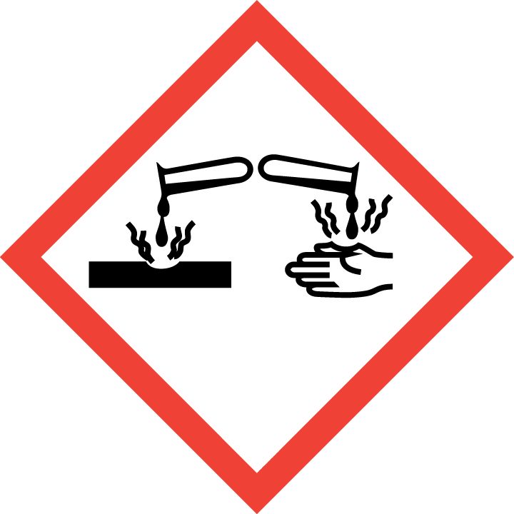
Signal word (CLP): Danger
Hazard Statements (CLP): H318: Causes serious eye damage.
H315: Causes skin irritation.
Precautionary Statements (CLP): P102 - Keep out of reach of children
P280 Wear protective gloves/protective clothing/eye protection/face protection.
P301+P330+P331 IF SWALLOWED: Rinse mouth. Do NOT induce vomiting.
P302 + P352 – IF ON SKIN: Wash with plenty of soap and water.
P332 + P313 – If skin irritation occurs: Get medical advice/attention.
P305+P351+P338 - IF IN EYES: Rinse cautiously with water for several minutes. Remove
contact lenses, if present and easy to do. Continue rinsing
P337+P313 - If eye irritation persists: Get medical advice/attention

The full texts for all H- and EUH-phrases are displayed in Section 16 ‘Other Information’.

2.3 Other Hazards

Other hazards not contributing
to the classification: No presence of PBT and vPvB ingredients.

3. Composition/information on ingredients:

Common Name CAS No./ EC No. Classification Conc (%)
Accoding to (EC) 1272/2008 (CLP)

SODIUM CARBONATE PEROXIDE 15630-89-4 Ox Sol. 3, H272 15 - 30
239-707-6 Acute Tox. 4, H302
Eye Dam. 1, H318

SODIUM SILICATE PENTAHYDRATE 6834-92-0 Skin Corr. 1B: H314 15 - 30
229-912-9 STOT SE3, H335

SODIUM CARBONATE 497-19-8 Eye Irrit. 2, H319 15 - 30
207-838-8

SODIUM C10-C12 BENZENE SULPHONATE 25155-30-0/ 68081-81-2 Acute Tox. 4 (Oral), H302 1 - 5
246-680-4 Skin Irrit. 2, H315
Eye Dam. 1, H318
STOT SE 3, H335

ALCOHOL ETHOXYLATE C14-15 PARETH-7EO 68951-67-7 Acute Tox. 4 (Oral), H302 1 - 5
Polymer Eye Dam. 1, H318
Aquatic Acute 1, H400

The full texts for all H- and EUH-phrases are displayed in Section 16 ‘Other Information’.

4. First-aid measures
4.1. Description of first aid measures
First-aid measures after inhalation : IF INHALED: remove victim to fresh air and keep at rest in a position comfortable for breathing. Seek medical advice if you feel unwell.
First-aid measures after skin contact : IF ON SKIN: Wash with plenty of soap and water. If skin irritation occurs: Get medical advice/attention, and discontinue use of product.
First-aid measures after eye contact : IF IN EYES: Rinse cautiously with water for several minutes. Remove contact lenses, if present and easy to do. Continue rinsing. If eye irritation persists, immediately call a doctor.
First-aid measures after ingestion : IF SWALLOWED: rinse mouth. Do NOT induce vomiting. Drink plenty of water. Seek medical advice if you feel unwell.

4.2. Most important symptoms and effects, both acute and delayed
Symptoms/injuries after inhalation : Coughing. sneezing.
Symptoms/injuries after skin contact : Redness. Swelling. dryness. Itching.
Symptoms/injuries after eye contact : Severe pain. Redness. Swelling. Blurred vision.
Symptoms/injuries after ingestion : Oral mucosal or gastro-intestinal irritation. Nausea. Vomiting. Excessive secretion. Diarrhoea.

4.3. Indication of any immediate medical attention and special treatment needed
Refer to section 4.1.
SECTION 5: Firefighting measures
5. Fire fighting measures
Extinguishing media: Product itself is not explosive or flammable. The product itself will not burn. If anything, packaging may be involved in a fire. Use CO₂, dry chemical powder, alcohol resistant foam or other media appropriate for materials actually involved in the fire. If water is used, contain run-off.
Special hazards: When heated sufficiently, product may decompose to form smoke and toxic fumes.
Special protective equipment: Fire fighters should wear approved self-contained breathing apparatus and full protective clothing.

6. Accidental release measures
Personal precautions:
Avoid contact with skin and eyes. For appropriate personal protection see section 8.
Environmental precautions:
Although this product is suitable for down the drain disposal it is advised that as much of the solid is contained and scooped up, before final dispersal of any residue with water.
Methods and material for containment and clean-up:
Prevent leakage into sewers or surface water by utilising bunding, absorbent booms, drain covers and soil or sand dikes. Contact appropriate environmental protection agencies, (Environment Agency in the UK) and local water authorities if significant contamination occurs.
For small and large spills: scoop spillage into suitable plastic containers and rework/dispose as per local legislation.

7. Handling and storage
Precautions for safe handling:
Avoid contact with neat product on skin and eyes. Wear protective clothing as per section 8.

Storage precautions:
Store in closed original container in a cool and dry area.

8. Exposure controls / personal protection
8.1. Control parameters
Sodium Carbonate (CAS 497-19-8)
DNEL/PNEC Values
DNEL/DMEL (Workers)
Long-term - local effects, inhalation 10 mg/m³
DNEL/DMEL (General population)
Acute - local effects, inhalation 10 mg/m³

SODIUM PERCARBONATE (CAS 15630-89-4)
DNEL/PNEC Values
Type Exposure Value Population Effect
DNEL Inhalation 5 mg/m3 Workers Local
DNEL Dermal 12.8 mg/cm2 Workers Local
DNEL Dermal 6.4 mg/cm2 Consumers Local
PNEC Environmental: Water 35 g/l - -
PNEC Environmental: STP 16 mg/l - -

8.2. Exposure controls
8.2.1. Appropriate engineering controls: Not applicable.
8.2.2. Personal protective equipment
Hand protection: Wear gloves during direct contact and hand-washing.
Eye protection: Wear eye/face protection.
Skin and body protection: Not applicable.
Respiratory protection: Not applicable.

8.2.3. Environmental exposure controls:
No particular measures required

9. Physical and chemical properties

Appearance: White powder
Odour: Non detectable
pH (10% aqueous solution) : ca. 11
Melting point: Not determined
Boiling point: Not determined
Flash point: Not combustible
Evaporation rate: Not determined
Flammability: Not combustible
Explosive properties: Non-Explosive
Oxidising properties: Not determined
Vapour pressure/density: Not determined
Relative density: ca. Not Determined
Water solubility: Soluble
Partition coefficient: Not determined
Auto ignition temperature: Not combustible
Decomposition temperature: Not determined
Viscosity: Not determined

10. Stability and reactivity
Stability:
Stable under normal conditions.
Conditions to avoid:
None
Materials to avoid:
Do not mix with other cleaning products unless advised to do so by a professional from the industry.

11. Toxicological information
11.1 Information on toxicological effects
Acute Oral Toxicity:
May cause burns in mucous membranes, throat, oesophagus and stomach.
Acute Inhalation Toxicity:
Dusts may irritate throat and respiratory system and cause coughing.
Acute Dermal Toxicity:
Irritating/ damaging to skin
Skin Corrosion/Irritation:
May cause chemical burns of the skin. Prolonged contact may cause tissue damage.
Serious eye damage/eye irritation:
Causes burns. Risk of corneal damage. Visual disturbances including blurred vision.
Sensitisation:
Not expected to provoke a sensitisation reaction.
Repeated Dose Toxicity:
Not data available.
Assessment of STOT single exposure: No data available
Assessment of STOT repeated exposure: No data available
Risk of Aspiration Toxicity: No data available

Sodium Carbonate (CAS 497-19-8)
LD50 oral rat 2800 mg/kg
LD50 dermal rabbit 2001 mg/kg
ATE CLP (oral) 2800 mg/kg bodyweight
ATE CLP (dermal) 2001 mg/kg bodyweight

12. Ecological information
On the basis of raw materials and comparable substances contained in the product the following ecological evaluation is obtained.
Ecotoxicity: This product is intended for wide dispersive use, is not considered harmful to aquatic organisms and is compatible with the down-the-drain disposal route. No known adverse effects on the functioning of water treatment plants under normal use
conditions as recommended. The product is not considered harmful to aquatic organisms nor to cause long-term adverse effects in the environment.
Persistence and degradability: This product has not been found to cause long-term adverse effects in the environment. The surfactants used in this product are biodegradable in line with the requirements of EU Detergent Regulation (EC) No 648/2004. Data to support this assertion are held at the disposal of the competent authorities of the Member States and will be made available to them, at their direct request or at the request of a detergent manufacturer.
Bioaccumulative potential: The surfactant ingredients of this product are not expected to bioaccumulate.
Mobility in soil: Not determined.

13. Disposal considerations
Consumer products ending up down the drain after use. Observe safe handling precautions and local legislation.
The product is not considered harmful to aquatic organisms nor to cause long-term adverse effects in the environment. The surfactants contained in this preparation comply with the biodegradability criteria as laid down in Regulation EC/648/2004 on detergents.

14. Transport information
UN No: None
Classification: Not classified as hazardous for transport.
UN proper shipping name: None
Transport hazard class: Not subject to ADR/IATA/IMDG/RID codes.
Packing group: None
Environmental hazards: None
Special precautions for user: None

15. Regulatory information
15.1. Safety, health and environmental regulations/legislation specific for the substance or mixture
15.1.1. EU-Regulations
No REACH Annex XVII restrictions. Contains no substance on the REACH candidate list
The surfactant(s) contained in this preparation complies(comply) with the biodegradability criteria as laid down in Regulation (EC) No.648/2004 on detergents. Data to support this assertion are held at the disposal of the competent authorities of the Member States and will be made available to them, at their direct request or at the request of a detergent manufacturer.

15.1.2. National regulations
No additional information available

15.2. Chemical safety assessment
No chemical safety assessment has been carried out

16. Other information
Usage and handling instructions are not mentioned on this Material Safety Data Sheet. The labelling of the product is indicated in Section 2.2.

The full text of the H- and EUH-phrases indicated in this safety data sheet are as follows:

Aquatic Acute 1: Acute aquatic toxicity, Category 1
Acute Tox. 4 (Oral): Acute toxicity (oral), Category 4
Eye Dam. 1: Serious eye damage/eye irritation, Category 1
Eye Irrit. 2: Serious eye damage/eye irritation, Category 2
Ox. Sol. 3: Oxidising Solids, Category 3
Skin Irrit. 2: Skin corrosion/irritation, Category 2
Skin Corr. 1: Skin corrosion, Category 1B
STOT SE 3: Specific target organ toxicity- single exposure, Category 3, Respiratory tract irritation
H272 May intensify fire; oxidiser
H302 Harmful if swallowed
H314 Causes severe skin burns and eye damage
H315 Causes skin irritation
H318 Causes serious eye damage
H319 Causes serious eye irritation
H335 May cause respiratory irritation
H400 Very toxic to aquatic life

The information given has been compiled with reference to the Chemicals (Hazard Information & Packaging For Supply) Regulations (CHIP4) 2009 as amended, the Registration, Evaluation, Authorisation & Restriction of Chemicals (REACH) Regulations, as amended, the Control of Substances Hazardous to Health Regulations (COSHH) 2002, as amended, and Regulation (EC) No 1272/2008 of the European Parliament and of the Council of 16 December 2008 on classification, labelling and packaging of substances and mixtures, amending and repealing Directives 67/548/EEC and 1999/45/EC, and amending Regulation (EC) No 1907/2006. This information also harmonises the provisions and criteria for the classification and labelling of substances, mixtures and certain specific articles within the Community, taking into account the classification criteria and labelling rules of the GHS.

Legal disclaimer: The above information is believed to be correct but does not purport to be all inclusive and shall be used only as a guide. This company shall not be held liable for any damage resulting from handling or from contact with the above product.

